**Chi-squared Distribution**

If *X*1*,X*2*,…,Xm* are *m*independent random variables having the [standard normal distribution](http://www.r-tutor.com/node/58), then the following quantity follows a **Chi-Squared** **distribution**with *m degrees of freedom*. Its [mean](http://www.r-tutor.com/node/35) is *m*, and its [variance](http://www.r-tutor.com/node/42) is 2*m*.

V = X21 + X22 + ⋅⋅⋅+ X2m ~ χ2(m)


Here is a graph of the Chi-Squared distribution 7 degrees of freedom

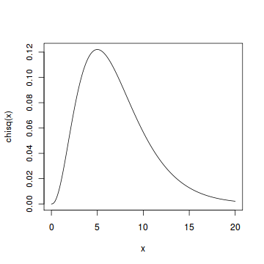

#### Problem

Find the 95*th* [percentile](http://www.r-tutor.com/node/38) of the Chi-Squared distribution with 7 degrees of freedom.

#### Solution

We apply the quantile function qchisq of the Chi-Squared distribution against the decimal values 0.95.

> qchisq(.95, df=7)        # 7 degrees of freedom   
[1] 14.067

#### Answer

The 95*th* percentile of the Chi-Squared distribution with 7 degrees of freedom is 14.067.